- Install Flask in a new Python virtual environment and create a file called app.py that displays 'Welcome to the Prediction API' at the root URL (/).

# Terminal :- python -m venv venv
# Command Prompt :- venv\Scripts\activate.bat
# Install :- pip install Flask
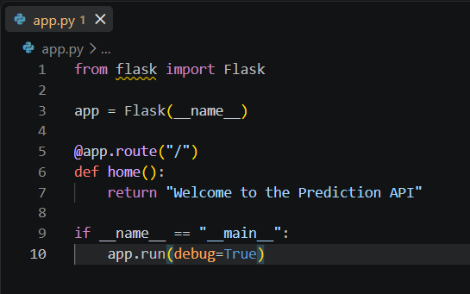

# Bash :- python app.py
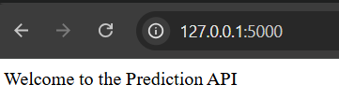

- Build a simple REST API in Flask called /predict-price that accepts a POST request with JSON input containing 'base_price' and 'discount' fields, and returns the final price after applying the discount.

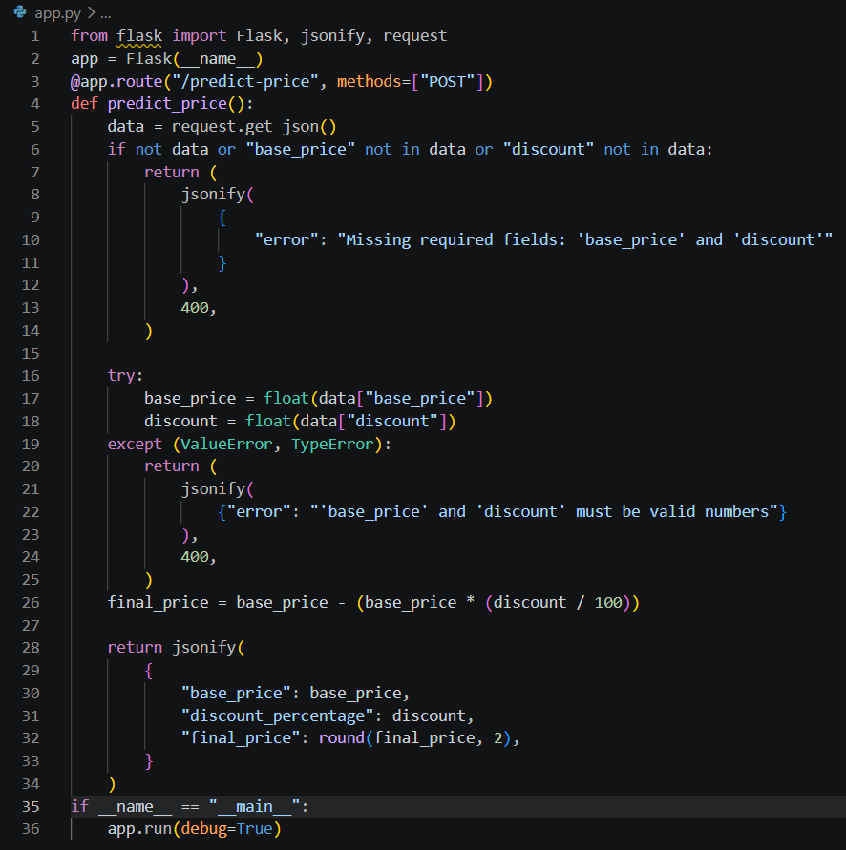

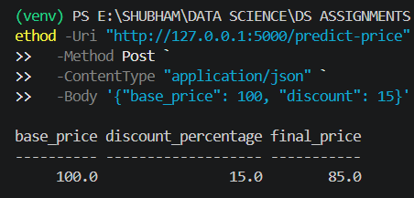

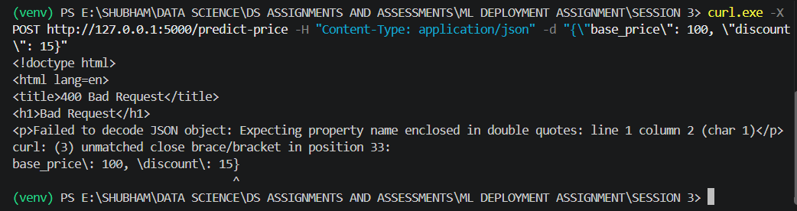

===========================================================================

- Save a trained scikit-learn LinearRegression model (for example, predicting delivery time based on distance and order size) to a file using joblib, then load this model in your Flask app and use it to make predictions when the /predict-delivery endpoint receives a POST request with JSON input.
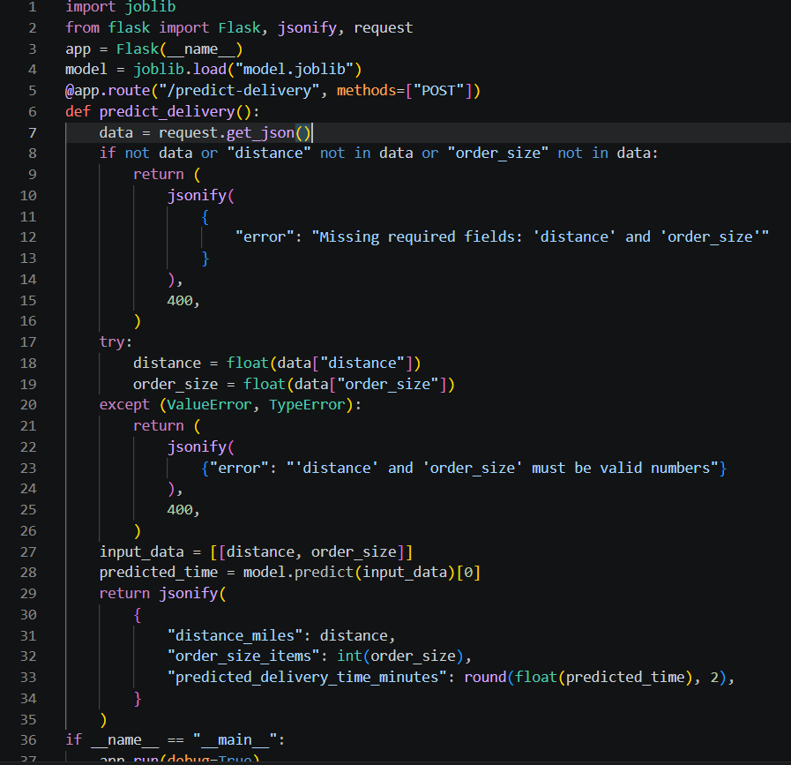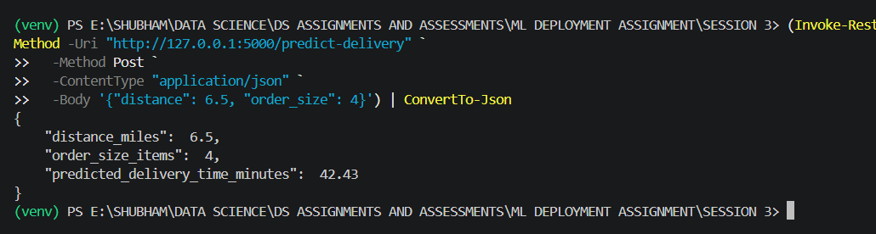

===========================================================================
- Update your Flask API so that it returns a JSON response with both the predicted value and a custom message, similar to how Swiggy or Zomato shows estimated delivery time and a friendly note.
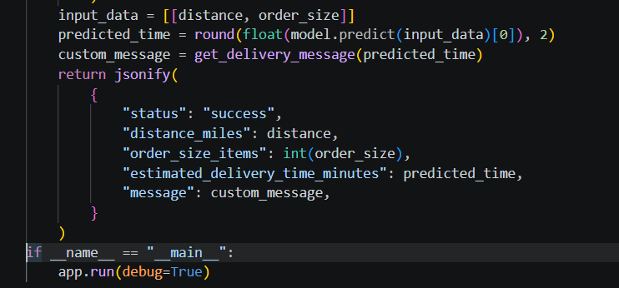

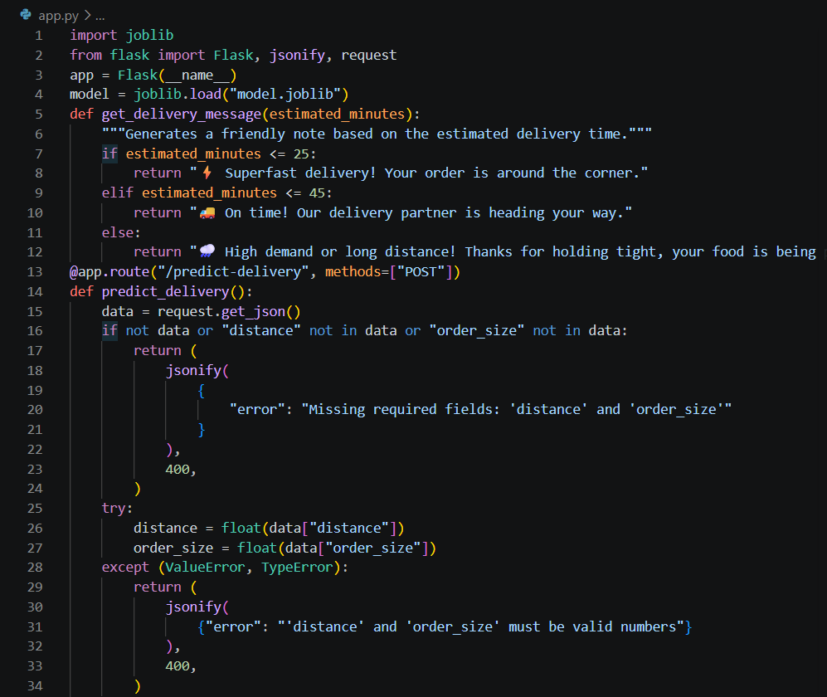

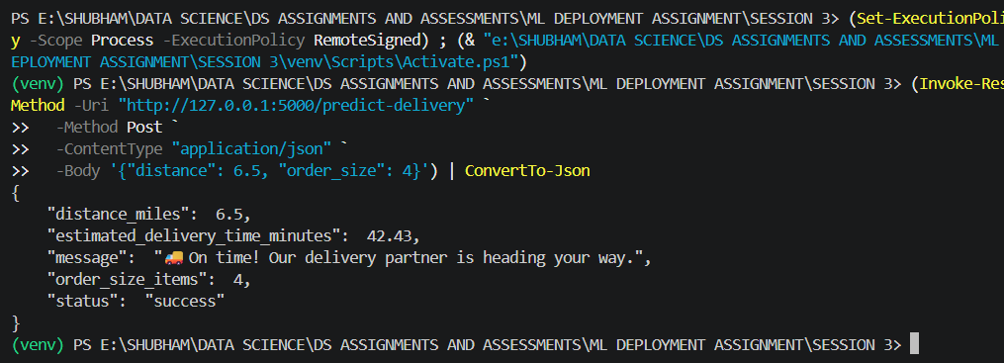

- Run your Flask prediction API locally, then use Postman or curl to send a sample JSON request to your /predict-delivery endpoint and verify the response. If you get a CORS or content-type error, check your request headers and Flask route methods.
